**PATUAKHALI SCIENCE AND TECHNOLOGY UNIVERSITY**

**COURSE CODE CIT-112**

**SUBMITTED TO:**

### **Md. Mahbubur Rahman**

### **Department of Computer Science and Information Technology**

**Faculty of Computer Science and Engineering**

**SUBMITTED BY:**

**Md. Sharafat Karim**

ID: **2102024**,

Registration No: **10151**

**Faculty of Computer Science and Engineering**

Date of submission: **30 May, 2023**

**Assignment: 06 (Basic Code)**

Table of Contents

1) Reversing digits 3

2) Euler’s Number 4

3) Functions calculate 5

4) Present value 7

5) Square of character S 9

6) sin(x) graph function 11

7) S square with middle O 13

8) postivie values 14

9) Colored line 15

10) Pattern pyramid center aligned 16

11) Pattern of floating island 18

12) Sum of the digits 20

13) left sided pattern 21

14) Fibonacci numbers 22

15) Investment equation 23

16) pattern with for loop 25

17) Age range 27

18) 2 curves 29

19) exponent table 32

20) S writing with loop 34

# 1) Reversing digits

#include<stdio.h>  
int main()  
{  
 int n;  
 scanf("%d", &n);  
  
 int reverse=0;  
 while (n>0)  
 {  
 reverse *= 10;  
 reverse += n % 10;  
 n /= 10;  
 }  
 printf("%d", reverse);  
}

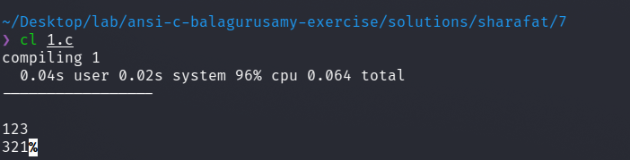

# 2) Euler’s Number

#include <stdio.h>  
  
int main()  
{  
 float accuracy = 0.00001;  
 float result=1, sum = 1;  
 int i = 1;  
  
 while ( sum > accuracy )  
 {  
 result += sum;  
 i++;  
 sum *= ((float)1/i);  
 }  
  
 printf("Result -> %f", result);  
}

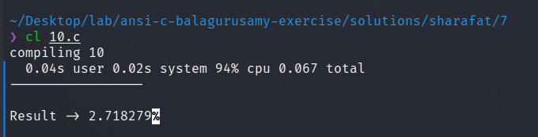

# 3) Functions calculate

#include <stdio.h>  
#include <math.h>  
  
int main()  
{  
 float accuracy = 0.0001, x;  
 scanf("%f", &x);  
 float result=1, sum = x;  
 int i = 1;  
  
 while ( sum > accuracy || sum < 0 )  
 {  
 result += sum;  
 i += 2;  
 sum *= (-1)*(x*x)/(i*(i-1));  
  
 if (i >= 100)  
 break;  
 }  
  
 printf("sinx -> %f\n", result);  
  
 result=1, sum = 1;  
 i = 0;  
  
 while ( sum > accuracy || sum < 0 )  
 {  
 result += sum;  
 i += 2;  
 sum *= (-1)*(x*x)/(i*(i-1));  
  
 if (i >= 100)  
 break;  
 }  
  
 printf("cosx -> %f\n", result);  
  
 result=1, sum = 1;  
 i = 0;  
  
 while ( sum > accuracy || sum < 0 )  
 {  
 result += sum;  
 i += 1;  
 sum *= pow(((float)1/i),i);  
  
 if (i >= 100)  
 break;  
 }  
  
 printf("SUM -> %f\n", result);  
}

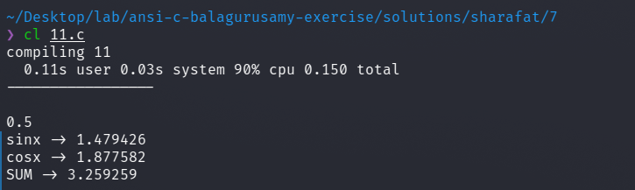

# 4) Present value

#include <math.h>  
#include <stdio.h>  
#include <ctype.h>  
  
int input(char name)  
{  
 int n;  
 printf("Enter the value of %c\n", name );  
 scanf("%d", &n);  
 if (n >= 0)  
 return n;  
 else  
 {  
 printf("Invalid input! Please try again\n");  
 printf("Value of P is -> %d", n);  
 return input(name);  
 }  
}  
  
int main()  
{  
 int n, c, d;  
 c = input('c');  
 d = input('d');  
 n = input('n');  
  
 int P;  
 P = c * pow(( 1 - (int)(d/100) ), n);  
 printf("Value of P is -> %d", P);  
  
 return 0;  
}

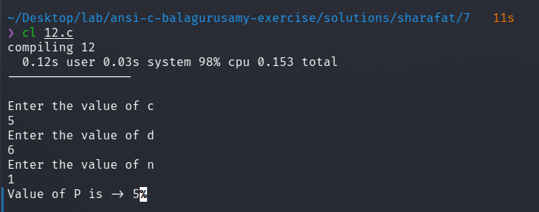

# 5) Square of character S

#include<stdio.h>  
  
int main()  
{  
 int i, j;  
 int col = 5;  
 char Char = 'S';  
  
 for (i=0; i< col; i++)  
 {  
 for (j=0; j<col; j++)  
 {  
 printf("%c ", Char);  
 }  
 printf("\n");  
 }  
  
 printf("\n");  
  
 for (i=0; i< col; i++)  
 {  
 for (j=0; j<col; j++)  
 {  
 if (i==0||j==0||i==col-1||j==col-1)  
 printf("%c ", Char);  
 else  
 printf(" ");  
 }  
 printf("\n");  
 }  
}

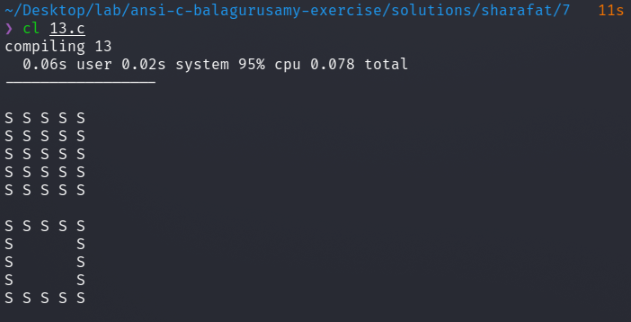

# 6) sin(x) graph function

#include <stdio.h>  
#include <math.h>  
  
/*  
x y  
--------------------------  
0 0.000000  
15 0.258819  
30 0.500000  
45 0.707107  
60 0.866025  
75 0.965926  
90 1.000000  
105 0.965926  
120 0.866025  
135 0.707107  
150 0.500000  
165 0.258819  
180 0.000000  
*/  
  
#define PI 3.14159265  
int main()  
{  
 int i;  
 float j, s;  
 for (j=1.1; j >= 0; j-=0.1)  
 {  
 for (i=0; i<= 180; i+= 15)  
 {  
 s = sin(i*PI/180);  
 if (fabsf(s-j)<=0.1)  
 {  
 printf("*");  
 }  
 else {  
 printf(" ");  
 }  
 }  
 printf("\n");  
 }  
}

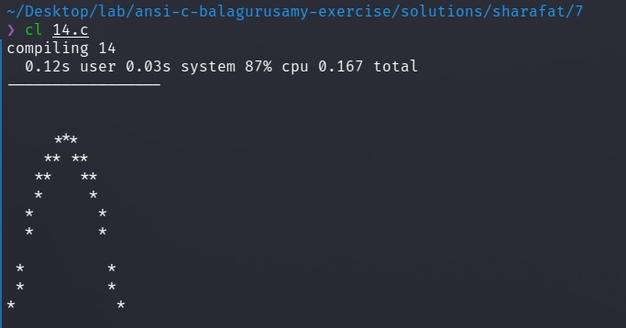

# 7) S square with middle O

#include<stdio.h>  
  
int main()  
{  
 int i, j;  
 int col = 5;  
 char Char = 'S';  
 char Char2 = 'O';  
  
 for (i=0; i< col; i++)  
 {  
 for (j=0; j<col; j++)  
 {  
 if (i==j && i==2)  
 printf("%c ", Char2);  
 else  
 printf("%c ", Char);  
 }  
 printf("\n");  
 }  
}

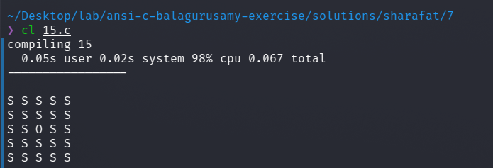

# 8) postivie values

#include<stdio.h>  
  
int main()  
{  
 int i, j;  
 int sum=0;  
  
 for (i=0; i< 10; i++)  
 {  
 scanf("%d", &j);  
 sum += j;  
 printf("%d + ", j);  
 }  
 printf("\nSum -> %d", sum);  
}  
  
// test case  
// 1 2 3 4 5 6 7 8 9 10

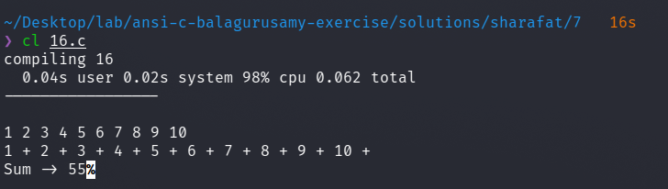

# 9) Colored line

#include <stdio.h>  
void red () {  
 printf("\033[1;31m");  
}  
  
void yellow() {  
 printf("\033[1;33m");  
}  
  
void reset () {  
 printf("\033[0m");  
}  
  
int main () {  
 red();  
 printf("Hello ");  
 yellow();  
 printf("world\n");  
 red();  
 printf("---------------------------\n");  
 reset();  
 return 0;  
}

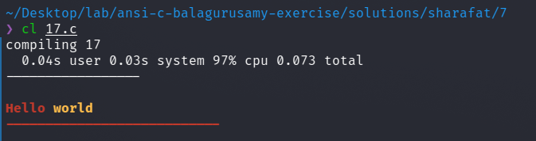

# 10) Pattern pyramid center aligned

#include<stdio.h>  
  
int main()  
{  
 int i, j;  
 int digit=1;  
 char letter='A';  
 int n;  
 scanf("%d", &n);  
  
 for (i=0; i< n; i++)  
 {  
 for (j=0; j<(5-i);j++)  
 printf(" ");  
 for (j=0; j<= i; j++)  
 {  
 if (i%2==0)  
 printf("%d ", digit++);  
 else  
 printf("%c ", letter++);  
 }  
 printf("\n");  
 }  
}

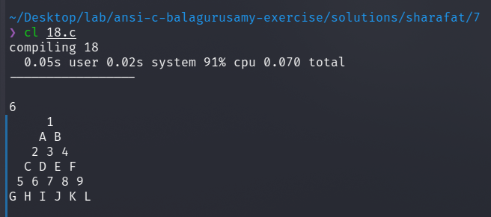

# 11) Pattern of floating island

#include<stdio.h>  
  
int main()  
{  
 int i, j;  
 int digit=1;  
 char letter='A';  
 int n;  
 scanf("%d", &n);  
  
 for (i=0; i< n/2; i++)  
 {  
 for (j=0; j<(5-i);j++)  
 printf(" ");  
 for (j=1; j<= i+1; j++)  
 printf("%d ", j);  
 for (j=j-2;j>=1;j--)  
 printf("%d ", j);  
 printf("\n");  
 }  
  
 for (i=n/2; i>= 0; i--)  
 {  
 for (j=0; j<(5-i);j++)  
 printf(" ");  
 for (j=1; j<= i+1; j++)  
 printf("%d ", j);  
 for (j=j-2;j>=1;j--)  
 printf("%d ", j);  
 printf("\n");  
 }  
}

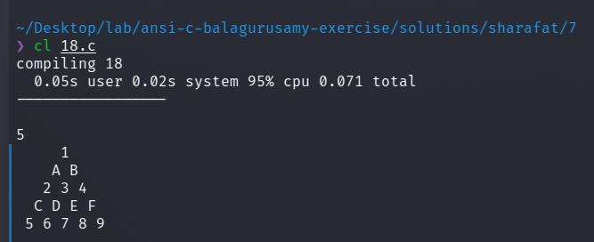

# 12) Sum of the digits

#include<stdio.h>  
int main()  
{  
 int n;  
 scanf("%d", &n);  
  
 int sum=0;  
 while (n>0)  
 {  
 sum += n % 10;  
 n /= 10;  
 }  
 printf("%d", sum);  
}

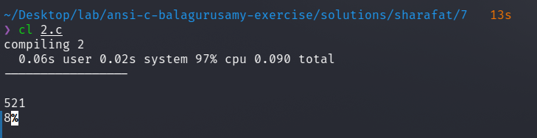

# 13) left sided pattern

#include<stdio.h>  
  
int main()  
{  
 int i, j;  
 int digit=1;  
 char letter='A';  
 int n;  
 scanf("%d", &n);  
  
 for (i=0; i< n; i++)  
 {  
 for (j=0; j<= i; j++)  
 printf("%d ", ((i+j)%2==0?1:0));  
 printf("\n");  
 }  
}

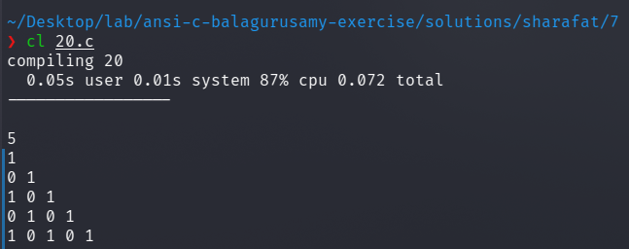

# 14) Fibonacci numbers

#include<stdio.h>  
int main()  
{  
 int n;  
 scanf("%d", &n);  
  
 int i=0, j=1, k=1, l=0, sum=0;  
 do  
 {  
 if ( i == 0 || i == 1 )  
 sum += 1;  
 else  
 {  
 sum += j + k;  
 l = j + k;  
 k = j;  
 j = l;  
 }  
 i++;  
 } while (i<n);  
 printf("%d", sum);  
}

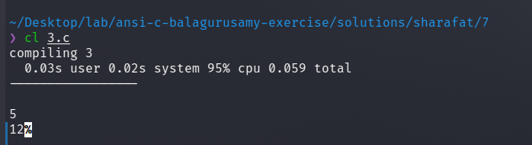

# 15) Investment equation

#include<stdio.h>  
int main()  
{  
 int n=1;  
 int p=1000, V ; float r=0.10;  
 do  
 {  
 V = p * (1+r);  
 printf("P - %d , V - %d , n - %d \n", p, V, n++);  
 p = V;  
 } while ( p <= 10000 );  
}

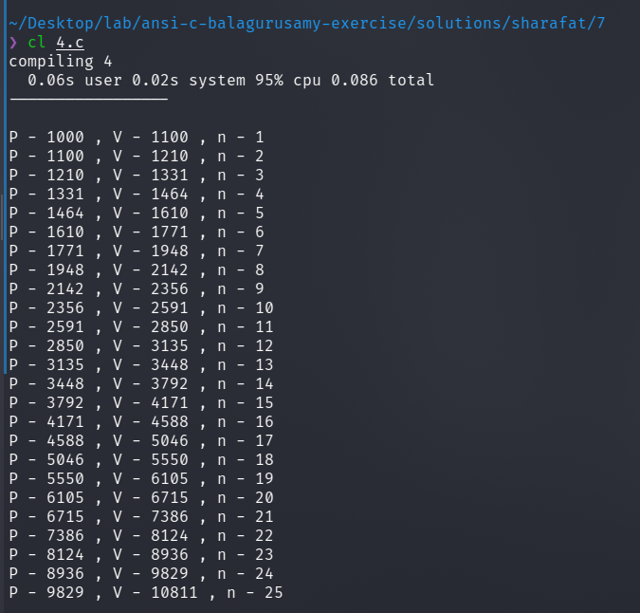

# 16) pattern with for loop

#include <stdio.h>  
  
int main()  
{  
 int n;  
 scanf("%d", &n);  
  
 int i, j;  
 for (i=0; i<n; i++)  
 {  
 for (j=1; j<=i+1; j++)  
 printf("%d ", i+1);  
 printf("\n");  
 }  
  
 printf("\n");  
  
 for (i=0; i<n; i++)  
 {  
 for (j=0; j<i; j++)  
 printf(" ");  
 for ( j=n-i ; j>0 ; j-- )  
 printf("* ");  
 printf("\n");  
 }  
}

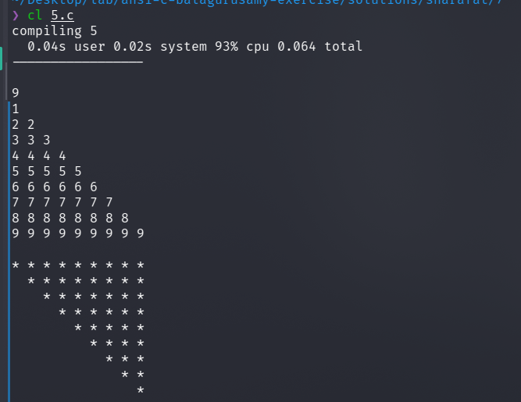

# 17) Age range

#include<stdio.h>  
  
int main()  
{  
 int i, j;  
 int sum = 0;  
  
 for (i=0; i<100; i++)  
 {  
 scanf("%d", &j);  
 if ( 50 <= j && j <= 60 )  
 {  
 sum++;  
 continue;  
 }  
 }  
 printf("total - %d", sum);  
}  
  
// test cases  
// 84 29 50 5 96 36 47 77 16 30 39 79 63 40 19 76 42 57 97 48 69 24 98 55 73 3 25 60 92 46 26 44 23 95 65 45 15 59 62 51 85 20 71 87 31 4 8 66 99 7 54 89 37 6 70 1 56 81 75 90 2 17 28 88 14 11 82 18 94 13 49 22 61 9 10 21 64 32 91 67 58 33 93 38 83 34 12 41 78 72 27 74 80 43 68 86 35 100 53 52

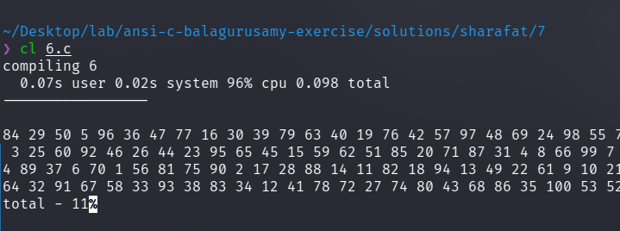

# 18) 2 curves

#include<stdio.h>  
#include <math.h>  
int main()  
{  
 int i;  
 float a, x, y1, y2;  
 a = 0.4;  
 printf(" y --------> \n");  
 printf("-------------------------------------\n");  
 for (x=0; x<5; x= x + 0.25)  
 {  
 y1 = (int) (50*exp(-a * x)+0.5);  
 y2 = (int) (50*exp(-a * x + x/2)+0.5);  
 if (y1 == y2)  
 {  
 if (x==2.5)  
 printf(" X |");  
 else  
 printf("|");  
 for (i=1; i <= y1-1; ++i)  
 printf(" ");  
 printf("#\n");  
 continue;  
 }  
 if (y1>y2)  
 {  
 if ( x == 2.5 )  
 printf(" X |");  
 else  
 printf(" |");  
 for (i=1; i <= y2-1; ++i )  
 printf(" ");  
 printf("*");  
 for ( i = 1; i <= (y1 - y2-1);++i)  
 printf("-");  
 continue;  
 }  
 if (x==2.5)  
 printf(" X |");  
 else  
 printf(" |");  
 for (i = 1; i <= (y1 - 1); ++i)  
 printf(" ");  
 printf("0");  
 for (i = 1; i <= (y2-y1-1); ++i)  
 printf("-");  
 printf("*\n");  
 }  
 printf(" |n");  
  
  
 float j, s;  
 for (j=1.1; j >= 0; j-=0.1)  
 {  
 for (i=0; i<= 5; i+= 0.5)  
 {  
 s = exp(-a * x);  
 if (fabsf(s-j)<=0.1)  
 {  
 printf("*");  
 }  
 else {  
 printf(" ");  
 }  
 }  
 printf("\n");  
 }  
}

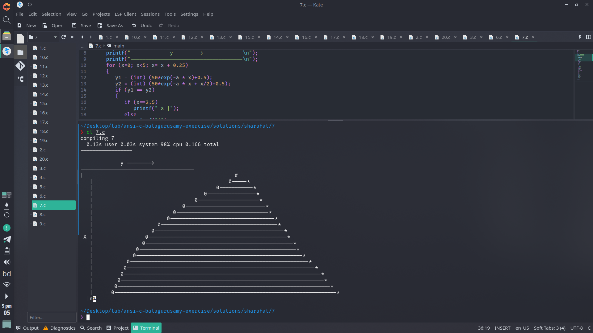

# 19) exponent table

#include<stdio.h>  
#include <math.h>  
  
int main()  
{  
 float x, y;  
 x = 0.0;  
  
 float i, j;  
 for (i=0; i<= (float)(0.91) ; i += 0.1)  
 {  
 if (i==0)  
 printf(" X ");  
 else  
 printf(" %.1f ", i);  
 }  
 printf("\n");  
  
 for (i=0; i<= 9 ; i += 1)  
 {  
 for (j=i; j<=i+0.91; j += 0.1)  
 {  
 if (j==i)  
 printf(" %.1f ", j);  
 else  
 printf(" %.1e ", exp(-j));  
 }  
 printf("\n");  
 }  
 printf("\n");  
}

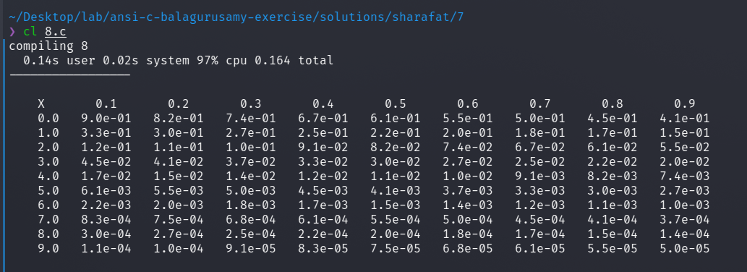

# 20) S writing with loop

#include <stdio.h>  
  
int main() {  
 int rows = 15;  
 int cols = 18;  
 int i, j;  
  
 for (i = 0; i < cols; i++)  
 printf("*");  
 printf("\n");  
  
 for (i = 0; i < cols; i++)  
 {  
 if (i < 2 || i > 15)  
 printf("*");  
 else  
 printf("-");  
 }  
 printf("\n");  
  
 for (i = 0; i < cols; i++)  
 {  
 if (i < 9 || i > 15)  
 printf("*");  
 else  
 printf("-");  
 }  
 printf("\n");  
  
 for (i = 0; i < cols; i++)  
 {  
 if (i < 4 )  
 printf("*");  
 }  
 printf("\n");  
  
 for (i = 0; i < cols; i++)  
 {  
 if (i < 4 )  
 printf("*");  
 }  
 printf("\n");  
  
 for (i = 0; i < cols; i++)  
 {  
 if (i < 4 )  
 printf("*");  
 }  
 printf("\n");  
  
 for (i = 0; i < cols; i++)  
 {  
 if (i < 5 || i > 13)  
 printf("*");  
 else  
 printf("-");  
 }  
 printf("\n");  
  
 for (i = 0; i < cols; i++)  
 {  
 if (i > 13)  
 printf("*");  
 else  
 printf("-");  
 }  
 printf("\n");  
  
 for (i = 0; i < cols; i++)  
 {  
 if (i > 13)  
 printf("*");  
 else  
 printf("-");  
 }  
 printf("\n");  
 for (i = 0; i < cols; i++)  
 {  
 if (i > 13)  
 printf("*");  
 else  
 printf("-");  
 }  
 printf("\n");  
 for (i = 0; i < cols; i++)  
 {  
 if (i > 13)  
 printf("*");  
 else  
 printf("-");  
 }  
 printf("\n");  
 for (i = 0; i < cols; i++)  
 {  
 if (i > 13)  
 printf("*");  
 else  
 printf("-");  
 }  
 printf("\n");  
 for (i = 0; i < cols; i++)  
 {  
 if (i > 13)  
 printf("*");  
 else  
 printf("-");  
 }  
 printf("\n");  
  
 for (i = 0; i < cols; i++)  
 {  
 if (i < 4 || i > 13)  
 printf("*");  
 else  
 printf("-");  
 }  
 printf("\n");  
  
 for (i = 0; i < cols; i++)  
 {  
 if (i < 3 || i > 13)  
 printf("*");  
 else  
 printf("-");  
 }  
 printf("\n");  
  
 for (i = 0; i < cols; i++)  
 {  
 if (i < 2 || i > 13)  
 printf("*");  
 else  
 printf("-");  
 }  
 printf("\n");  
  
 return 0;  
}

